Day-1 : Data Understanding & Profiling
- Business & Manufacturing KPIs before cleaning

- Total Production Quantity = Sum(total_qty)
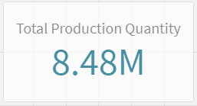
- Good Quantity = Sum(good_qty)
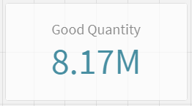
- Scrap Quantity = Sum(scrap_qty)
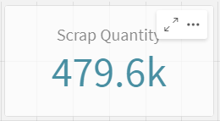
- Yield % = (Sum(good_qty) / Sum(total_qty)) * 100
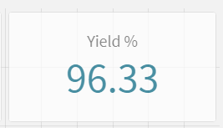

- Downtime Minutes = Sum(downtime_minutes)
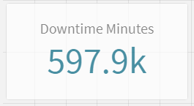

- Uptime % = (
(
Sum( Interval( Timestamp(shift_end_ts) - Timestamp(shift_start_ts), 'mm') ) - Sum( Interval( Timestamp(downtime_end_ts) -Timestamp(downtime_start_ts), 'mm') )
)
/
Sum( Interval( Timestamp(shift_end_ts) - Timestamp(shift_start_ts), 'mm') )
) * 100
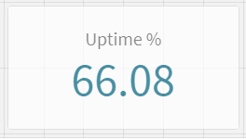

- OEE-style proxy = Availabilty * Quality
(
(
// Availability = (Scheduled - Downtime) / Scheduled
(
Sum( Interval( Timestamp(shift_end_ts) - Timestamp(shift_start_ts), 'mm') )
- Sum( Interval( Timestamp(downtime_end_ts) - Timestamp(downtime_start_ts), 'mm') )
)

/
Sum( Interval( Timestamp(shift_end_ts) - Timestamp(shift_start_ts), 'mm') )
)
*
// Quality = Good Qty / Total Qty
(
Sum(good_qty) / Sum(total_qty)
)
) * 100

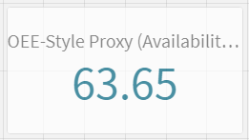

- Downtime Reason by Category
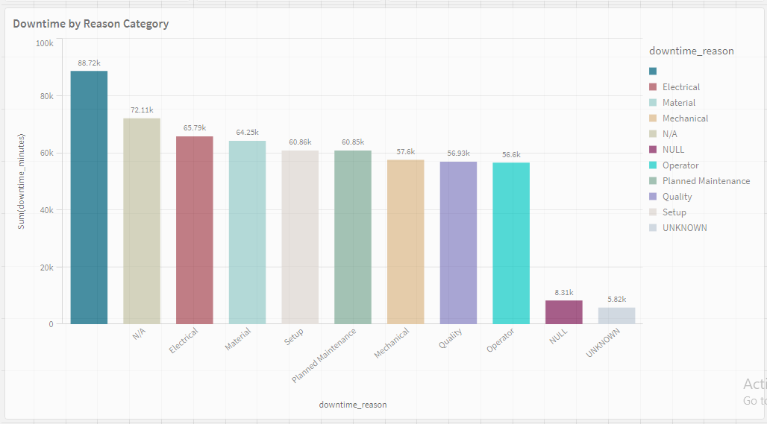

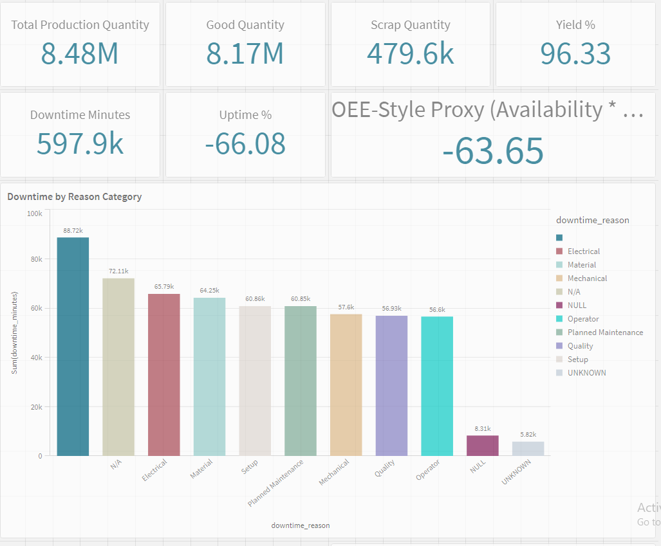
- Raw KPI’s Before Cleaning

- Raw Data Ingestion
Machine_downtime table
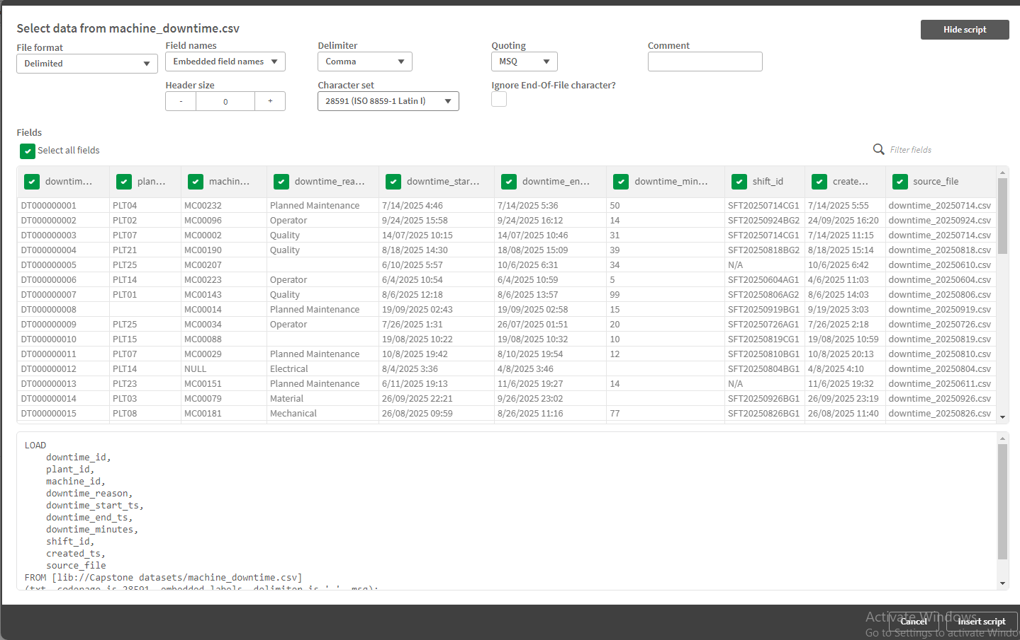
Calendar table
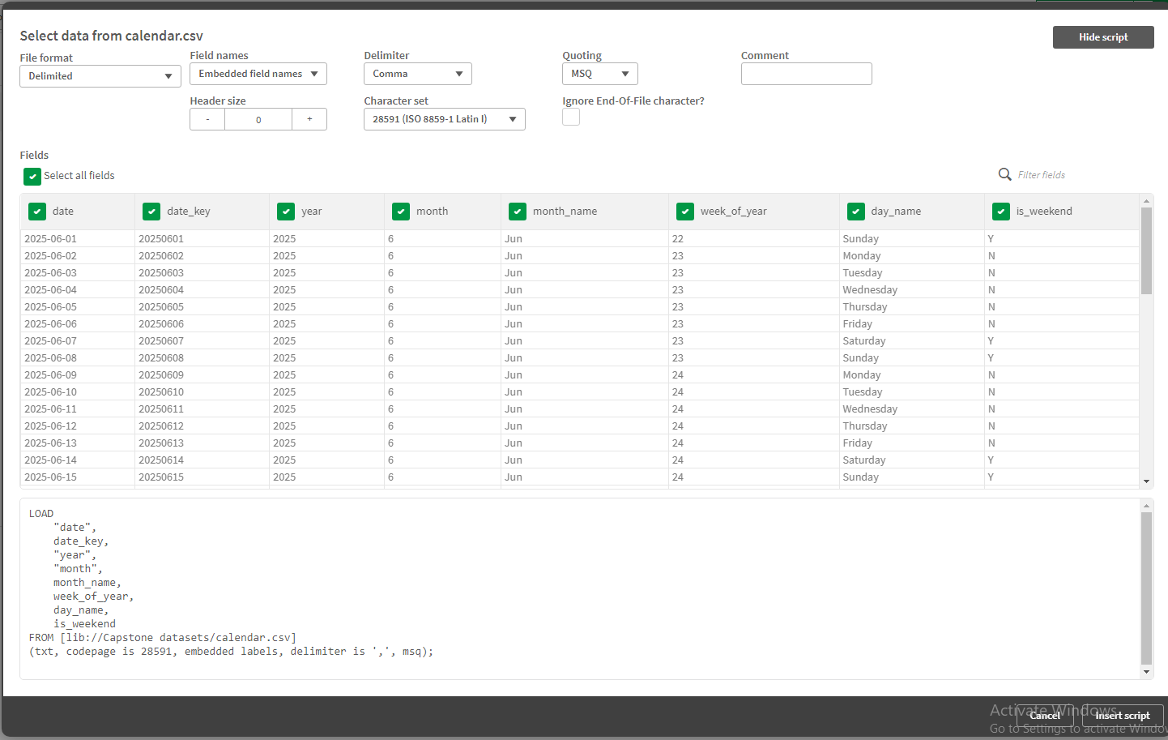
Plants table
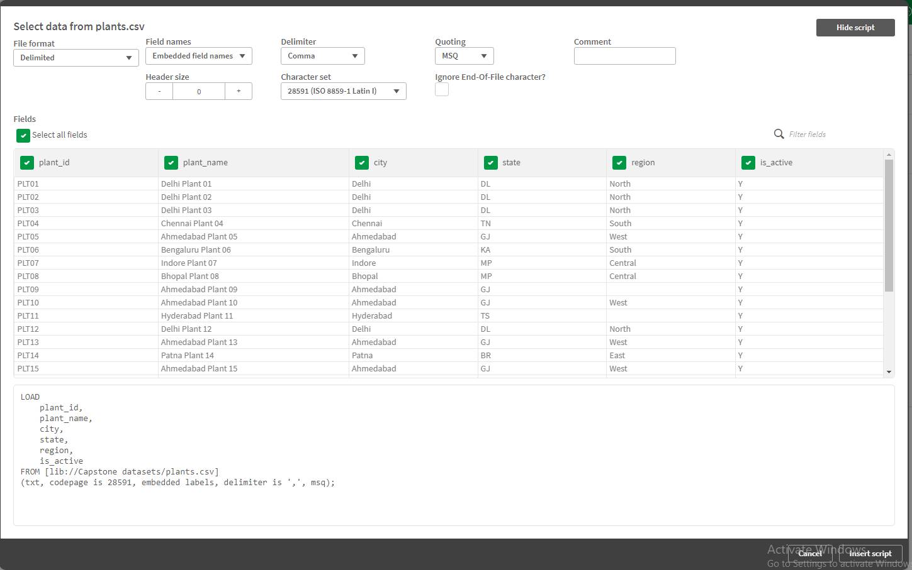
Production_batches table
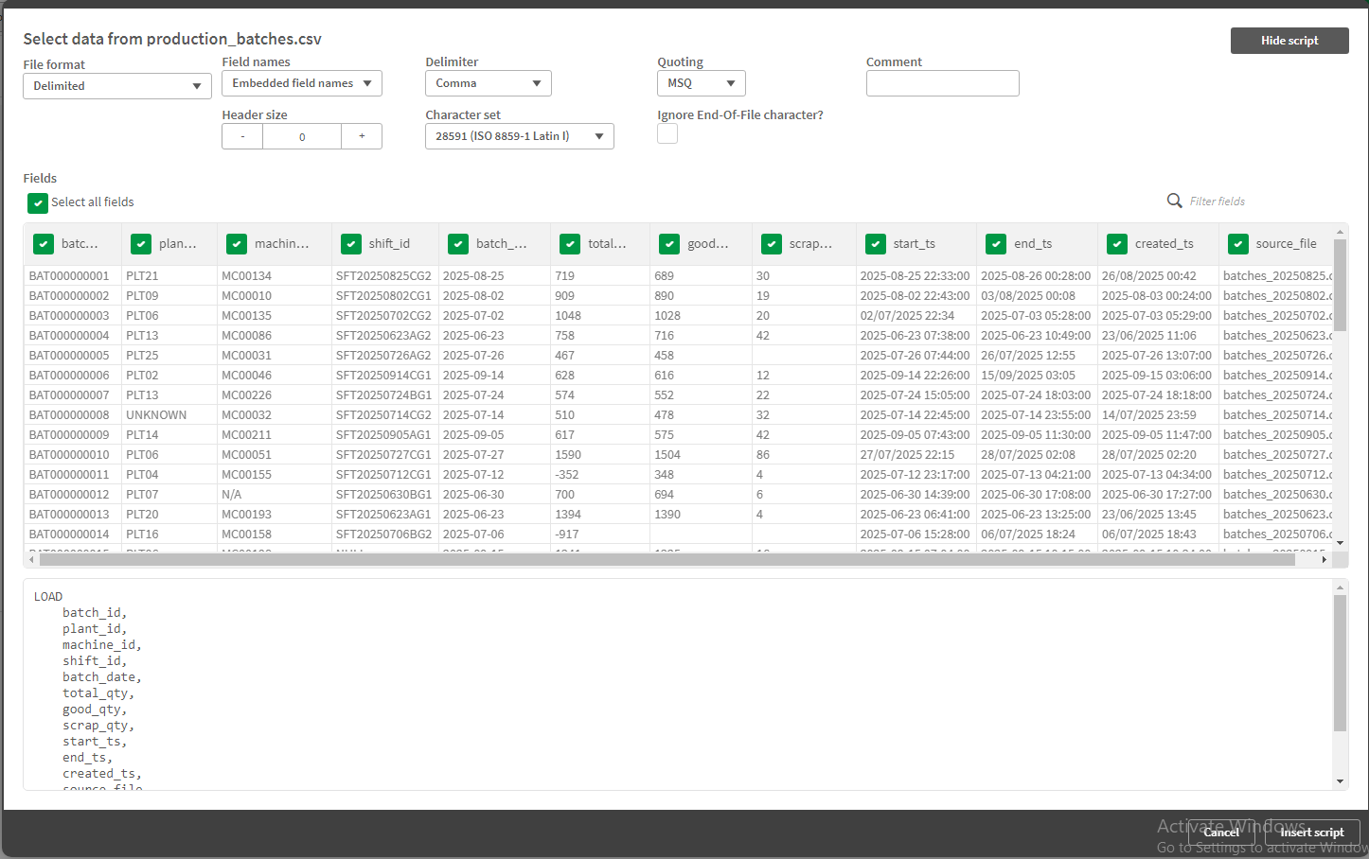
Shift Calendar Table
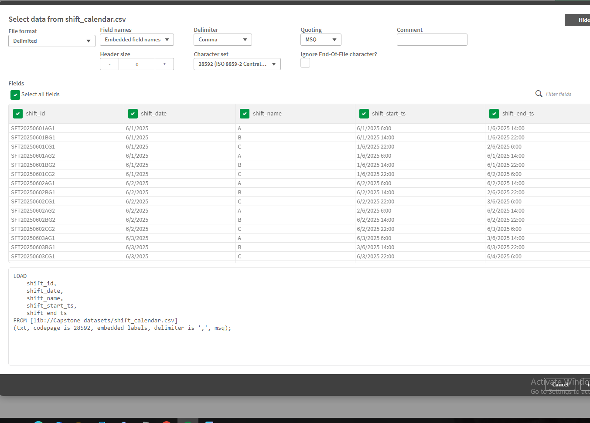
Machine Table
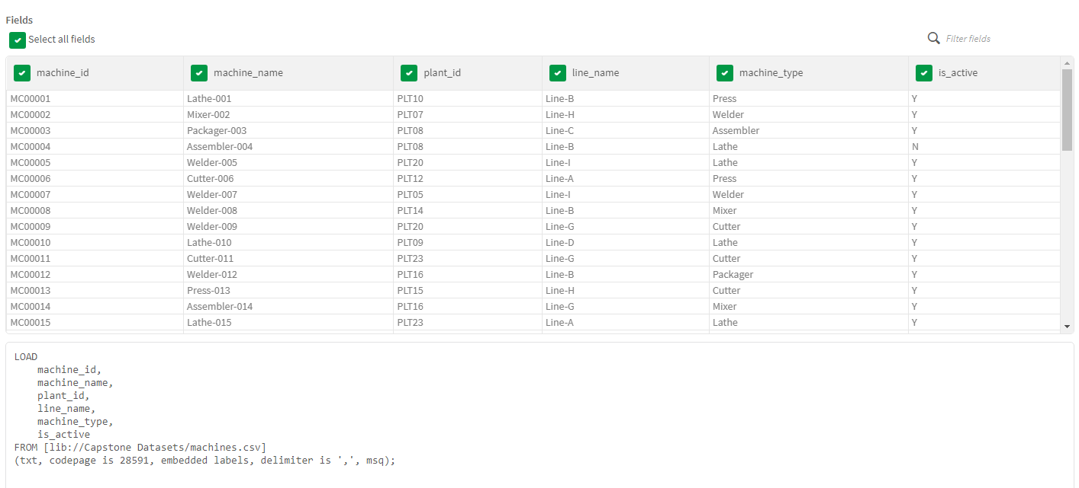

Load Editor Script to load all the tables
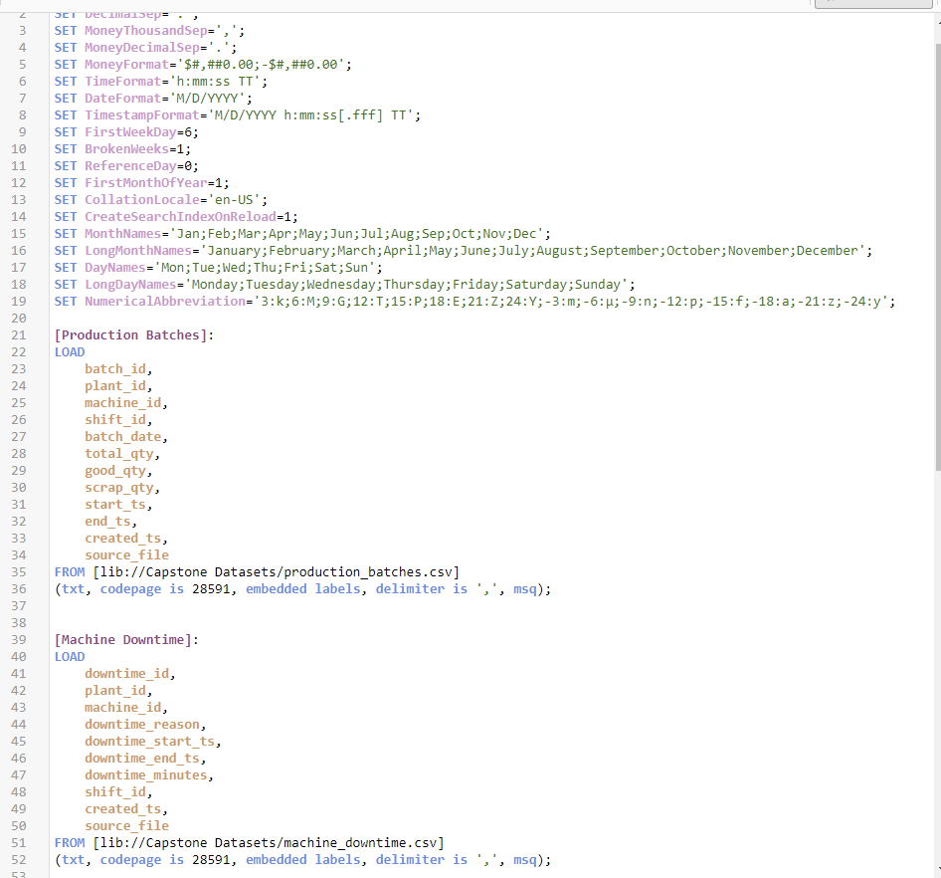

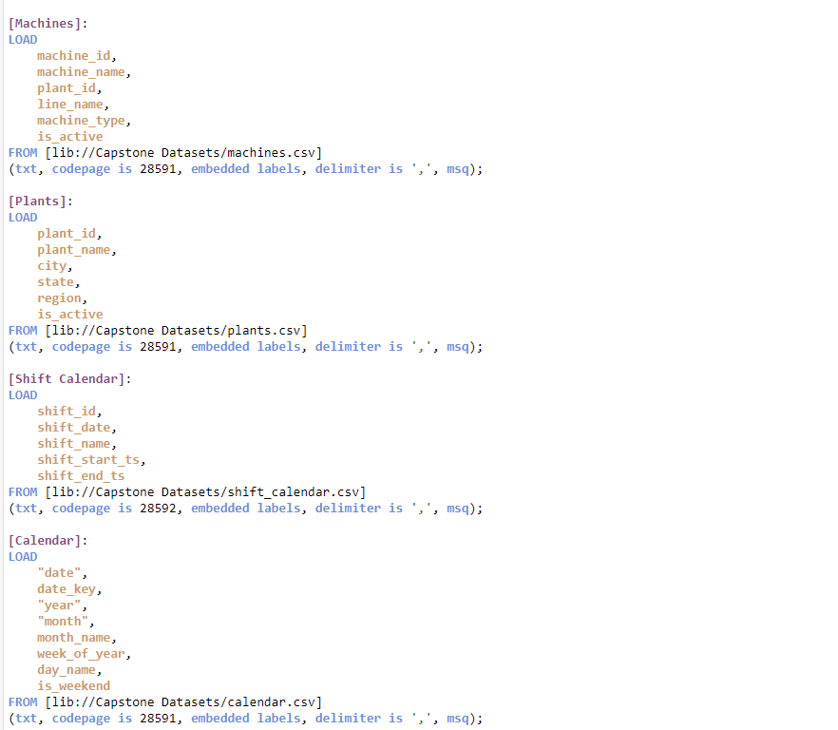
All Tables loaded and you can see them in the Data preview tab
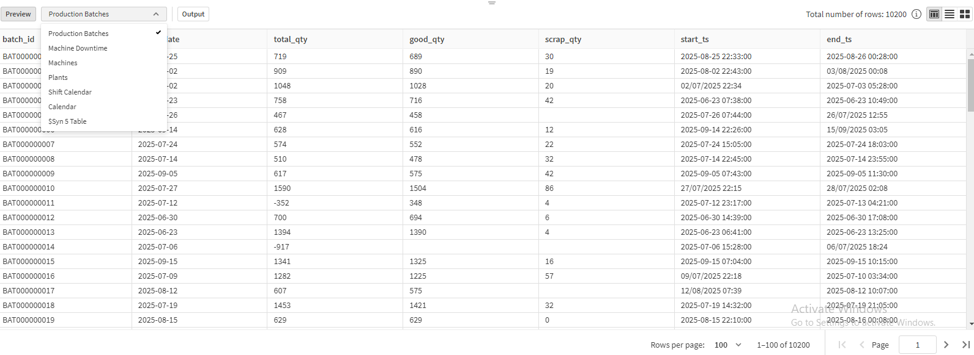
Synthetic Keys Generated
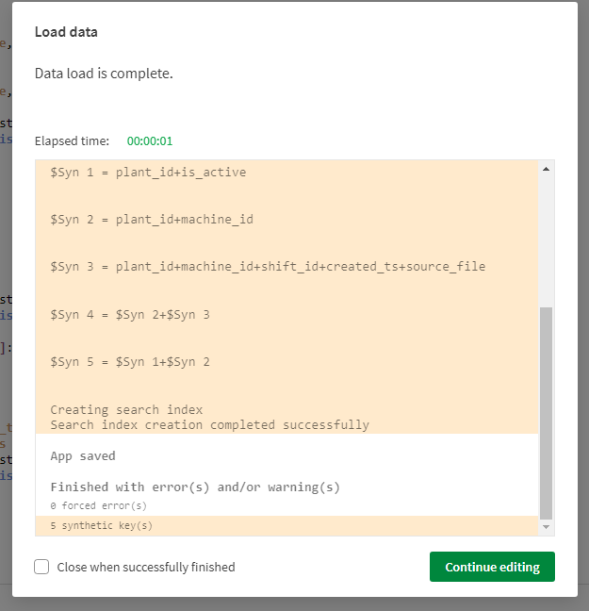

- Data Profiling & Diagnostics
- Mixed Datetime formats
Production_batches table
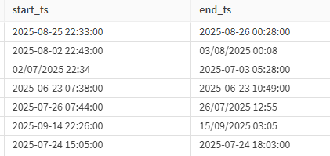

Machine Downtime table
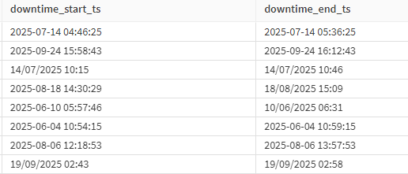

As observed, multiple datetime formats (such as DD-MM-YYYY, MM-DD-YYYY, YYYY-MM-DD, etc.) are present across the datasets.
Solution: To ensure consistency and prevent interpretation issues, a single standardized datetime format must be enforced for all datetime columns across all tables. All datetime values will be converted and stored in the unified format DD-MM-YYYY HH:MM:SS.

- Negative Quantities
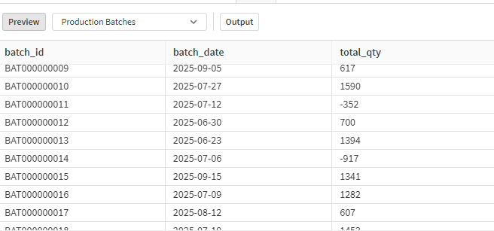
As observed, the Production Batches table contains negative values in the total_qty column.
Solution: These negative values must be converted to positive values to ensure data consistency and correctness.

- Scrap_qty > total_qty
Scrap quantity exceeding total quantity is an illogical condition.
Such records represent data inconsistencies and must be identified and flagged. The dataset contains rows where scrap_qty > total_qty, and these rows will be explicitly flagged for data quality and audit purposes rather than being corrected or removed.

- Downtime_end_ts < downtime_start_ts
This condition results in a time-order violation, where the end timestamp occurs before the start timestamp. The dataset contains records with this issue, and such records must be flagged for data quality and audit purposes.
Additionally, to ensure consistency and prevent interpretation errors, all datetime fields must be standardized to a single datetime format across the dataset.

- Null-heavy Downtime reasons
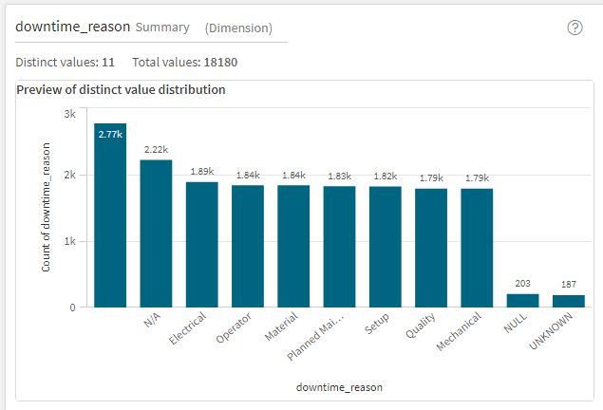

As observed, the dataset contains 2.72K blank entries, 2.22K entries with the value ‘N/A’, 203 entries containing the text ‘NULL’, and 187 entries containing the text ‘UNKNOWN’.
Profiling
- Downtime duration distribution
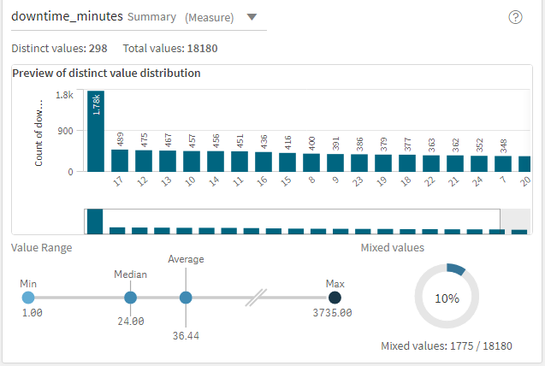

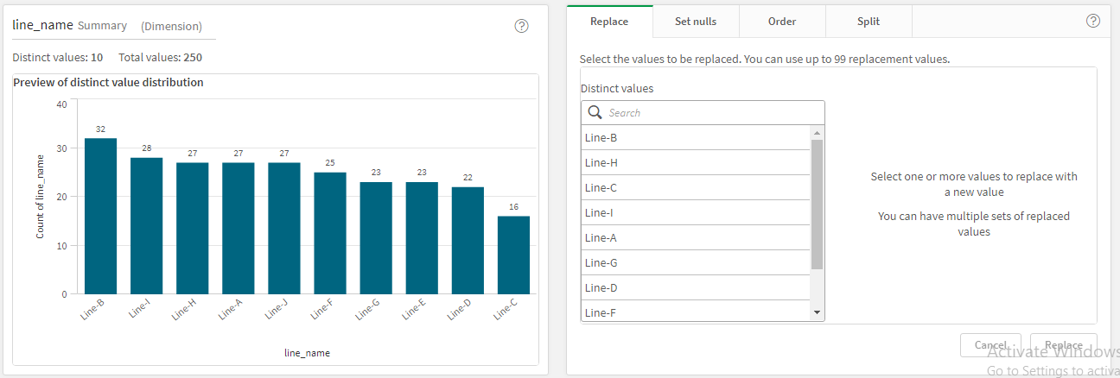
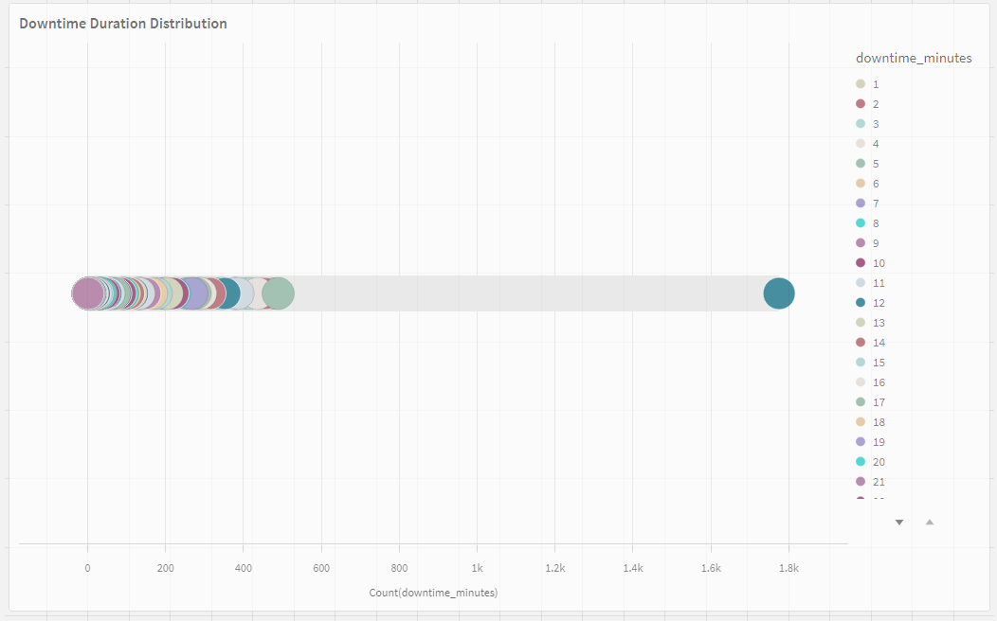
- Machine & Line Cardinality
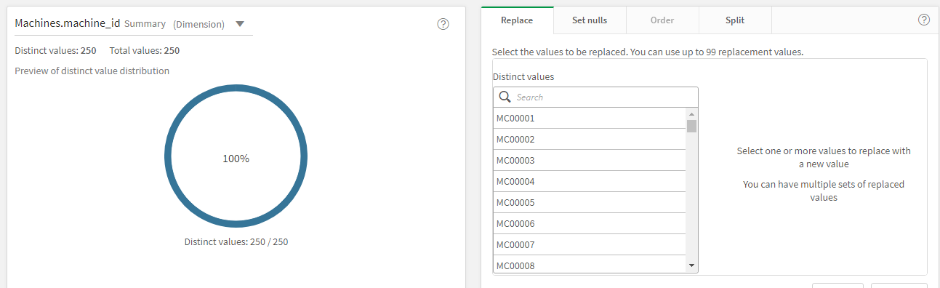
- Grain & Join Validation
- Fact Grains :
production_batches: 1 row = 1 batch per machine per shift
machine_downtime: 1 row = 1 downtime event per machine

To preserve the correct fact grain, both production_batches and machine_downtime tables were deduplicated by retaining only the most recent record for each unique batch_id and downtime_id, respectively. In cases where duplicate records existed, the row with the latest created_ts was preserved to ensure that the most up-to-date and accurate information is used for analysis. This approach keeps the data accurate and up to date, while avoiding duplicate records that could affect analysis.

- Join Validations :
Join validation was performed to ensure stable and accurate relationships across the data model. Each machine_id was verified to map to a single plant_id, enforcing a one-to-many relationship between plant and machines, while missing plant references were assigned as ‘UNKNOWN’ to prevent orphan records. Similarly, all production batch and downtime records were validated for shift_id availability, with missing values assigned as ‘UNKNOWN’, and shift boundaries—including night shifts crossing midnight—were handled consistently using the Shift Calendar to ensure reliable time-based analysis.

- Identify UNKNOWN dimension needs
Explicit handling of UNKNOWN dimensions will be essential in real manufacturing data to maintain data integrity. Dropping records with missing values will lead to data loss, while guessing values will result in incorrect analytics. Therefore, all missing, blank, or invalid values in key dimensions such as plant_id, machine_id, shift_id, and downtime_reason will be replaced with ‘UNKNOWN’. This will ensure that UNKNOWN is treated as a valid dimension member, allowing fact records to remain connected without breaking joins. As a result, data volume will be preserved, joins will remain intact, and data quality issues will be clearly visible for monitoring and audit purposes.

Day-2 : Data Cleansing & Time/Quantity Standardization
Plants table before cleaning
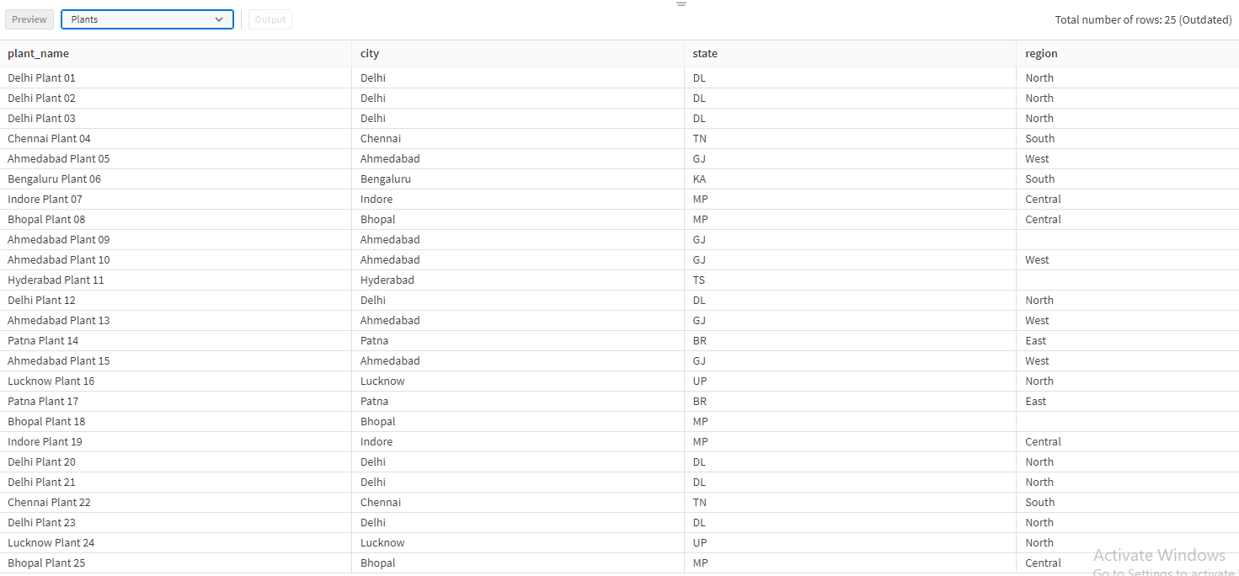
As observed, we have 3 blank values in Region Column
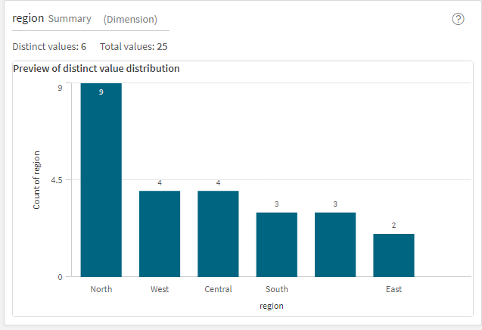
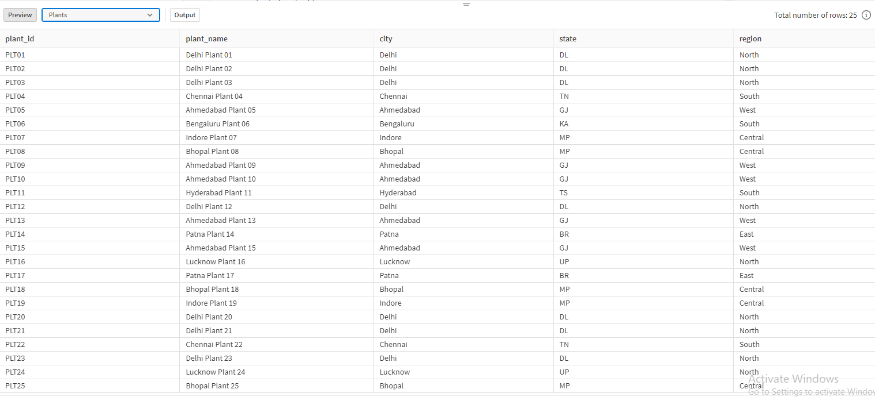
Plants table after cleaning

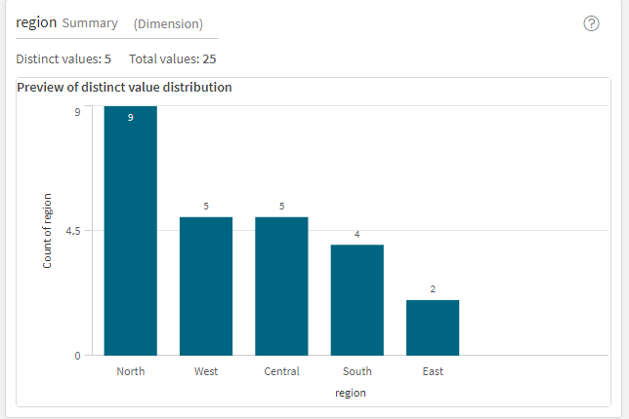
Load Editor Script for cleaning Plants Table
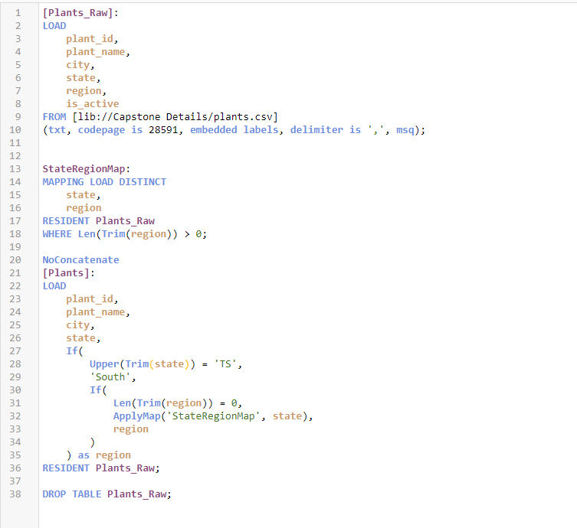

A state-to-region mapping table has been created to address missing values in the Region column. This mapping table is used to systematically derive and populate the appropriate region based on the corresponding state for each record. By applying this standardized mapping logic, blank or missing region values are filled consistently, ensuring regional data completeness and improving the accuracy of region-based analysis and reporting.

Machines Table before cleaning
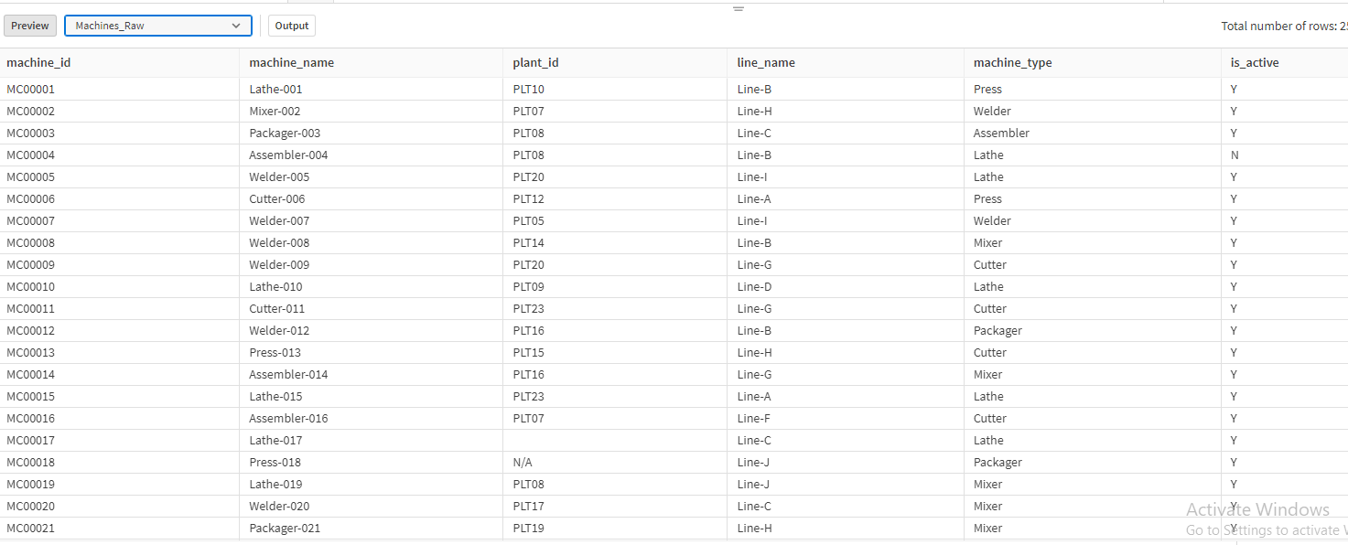
As observed, the plant_id column contains blank and ‘N/A’ values.
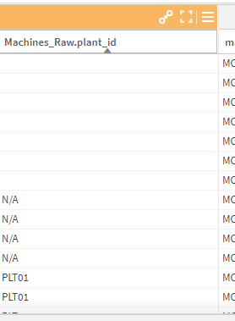

Machines Table after cleaning
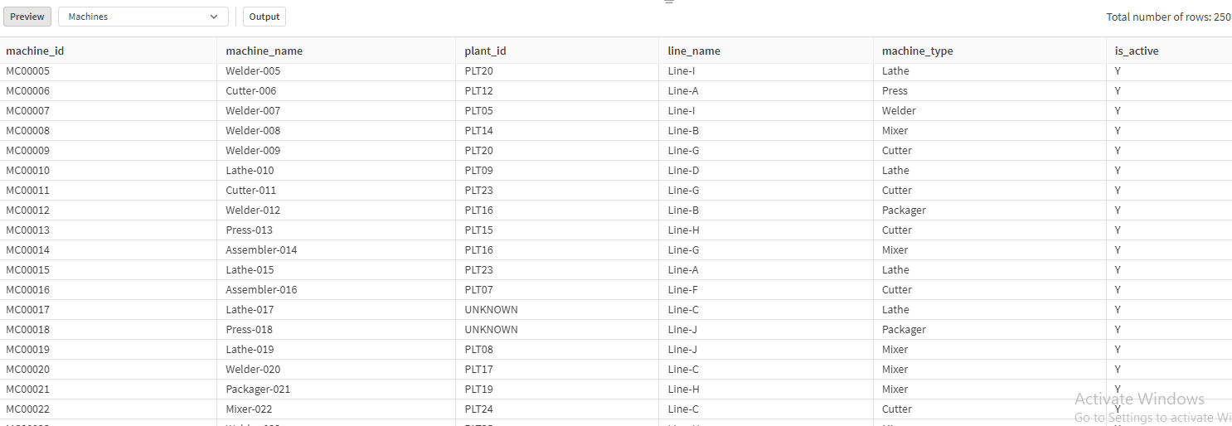

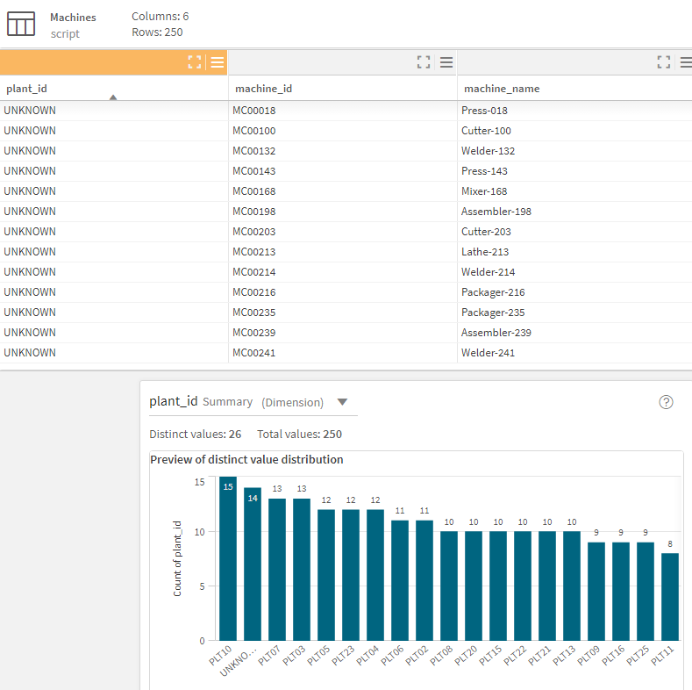
Load Editor Script for cleaning Machines Table
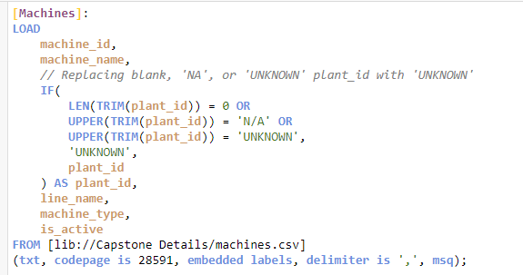

Any blank, ‘N/A’, or ‘UNKNOWN’ values encountered in the plant_id column will be replaced with ‘UNKNOWN’ to ensure consistency and maintain data integrity.

Production Batches before cleaning
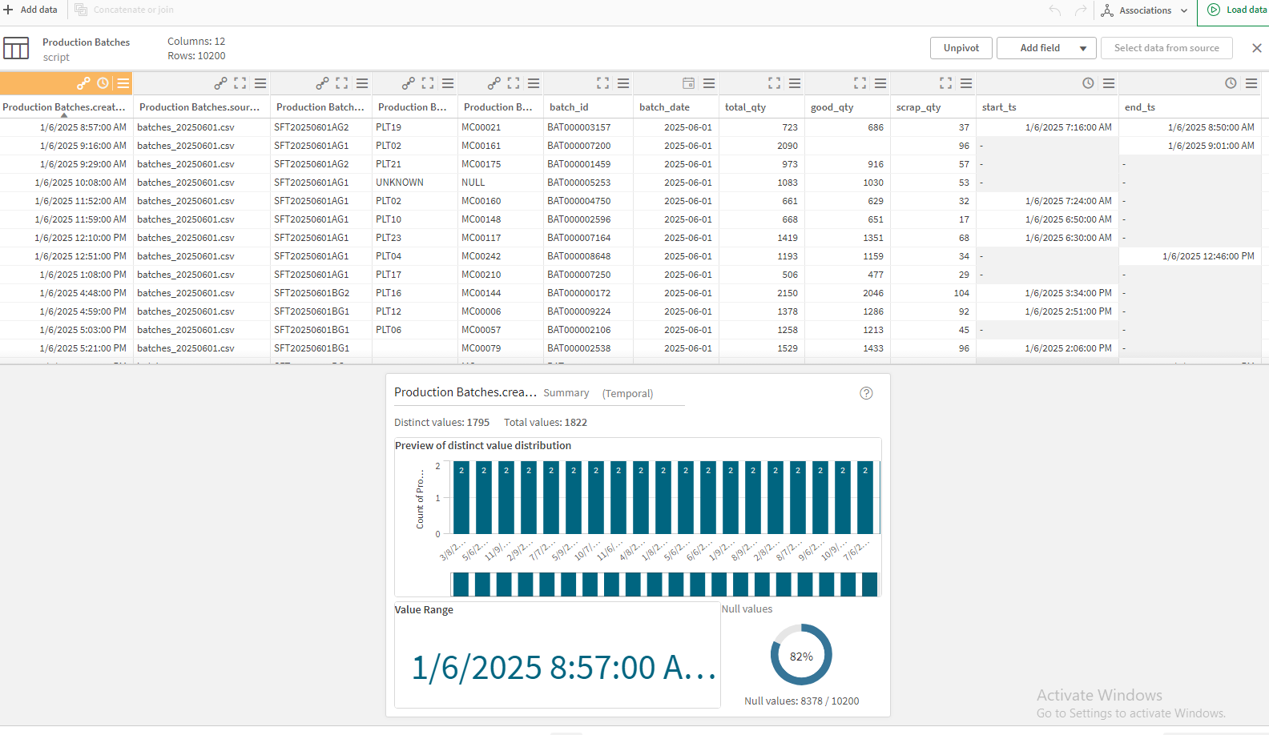
The plant_id, machine_id, and shift_id columns contained blank, NULL, ‘N/A’, and ‘UNKNOWN’ values. All such values have been consistently replaced with ‘UNKNOWN’ to ensure data completeness and maintain referential integrity across the dataset.

Load Editor Script to change this
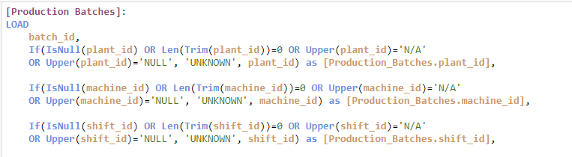

Additionally, the date formats in batch_date, start_ts, end_ts, and created_ts have been standardized to a single format, DD/MM/YYYY, to ensure consistency and prevent date interpretation issues across the dataset.
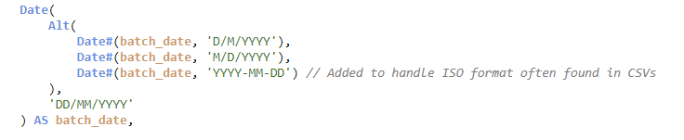
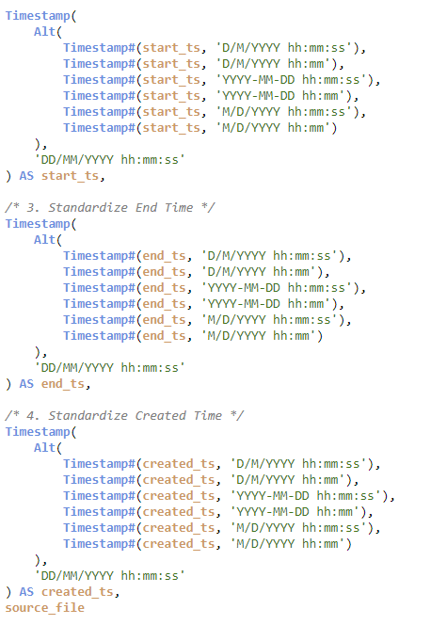
Handiling of negative values
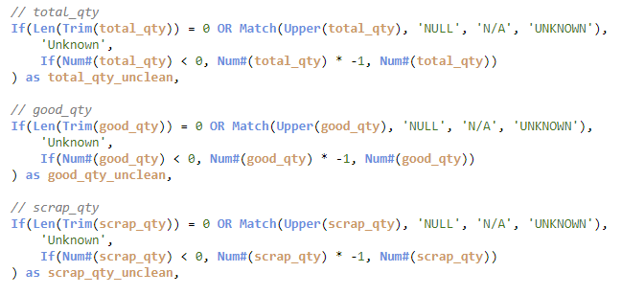
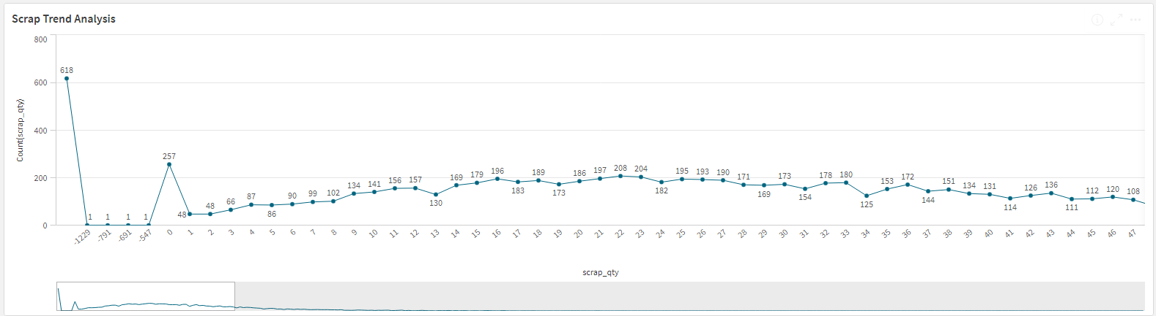
Scrap Trend Analysis before cleaning

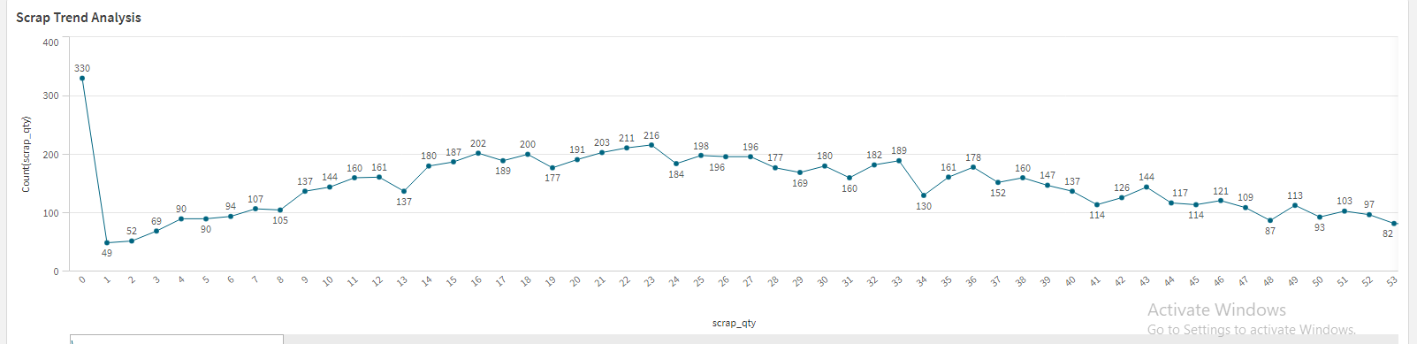
Scrap Trend Analysis after Cleaning

The dataset contains three numeric columns: total_qty, good_qty, and scrap_qty, which must adhere to the rule total_qty = good_qty + scrap_qty. If any one of these values is missing and the other two are available, the missing value is derived using this rule. If fewer than two values are available, the missing fields are set to zero, as the required calculation cannot be performed.
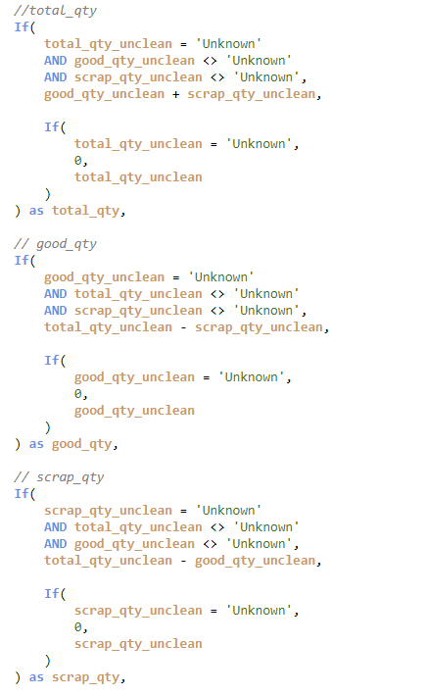
Deduplication
Duplicate batch_id records are removed while retaining the entry with the latest created_ts to ensure that only the most recent and accurate record is preserved.
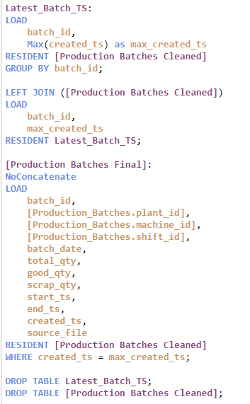
Row Count before De-duplication : 10200
Row Count after De-duplication : 10000

Creating three flag columns for outliers where (scrap_qty > total_qty) and (total_qty != good_qty + scrap_qty) and (start_ts > end_ts).
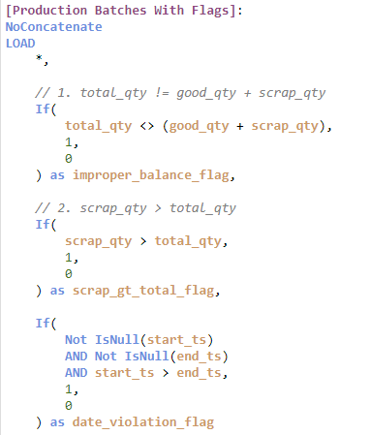
Three flag columns ‘improper_balance_flag’, ‘scrap_gt_total_flag’, ‘date_violation_flag’ are created.
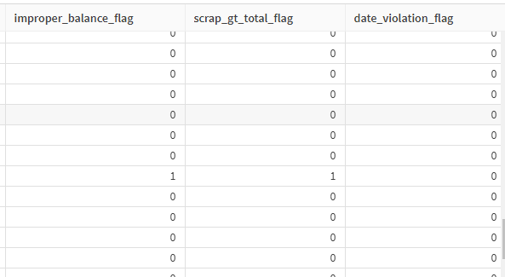
Production Batches table after cleaning
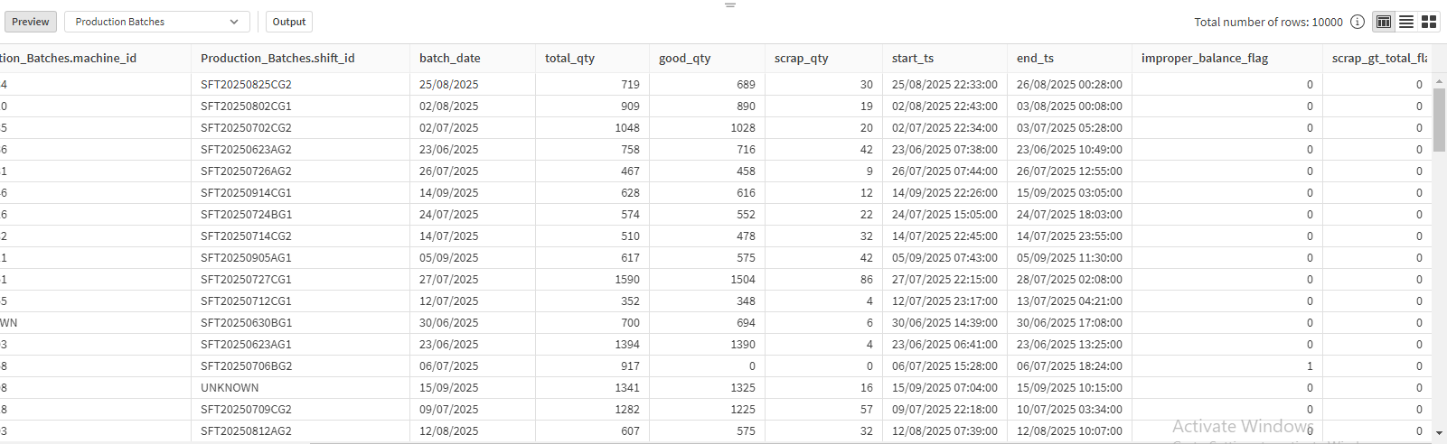

Calendar table before standardizing date format
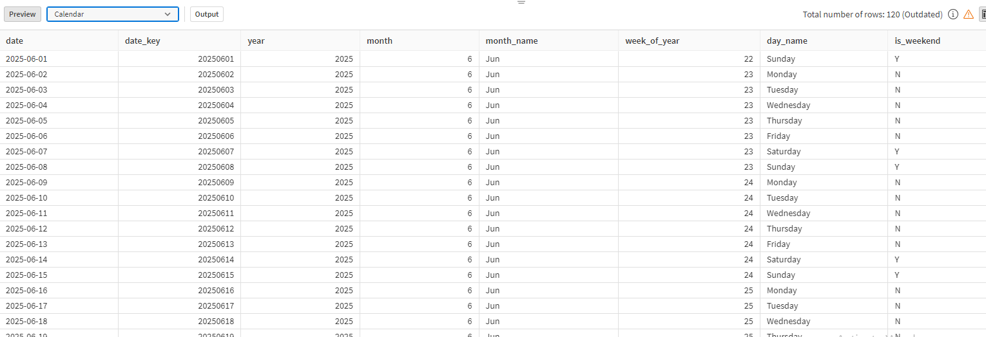

Load Editor Script to standardize
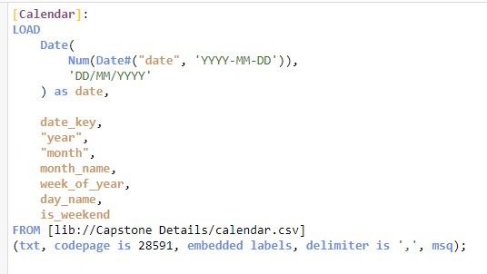
Calendar table after standardizing date format into dd/mm/yyyy
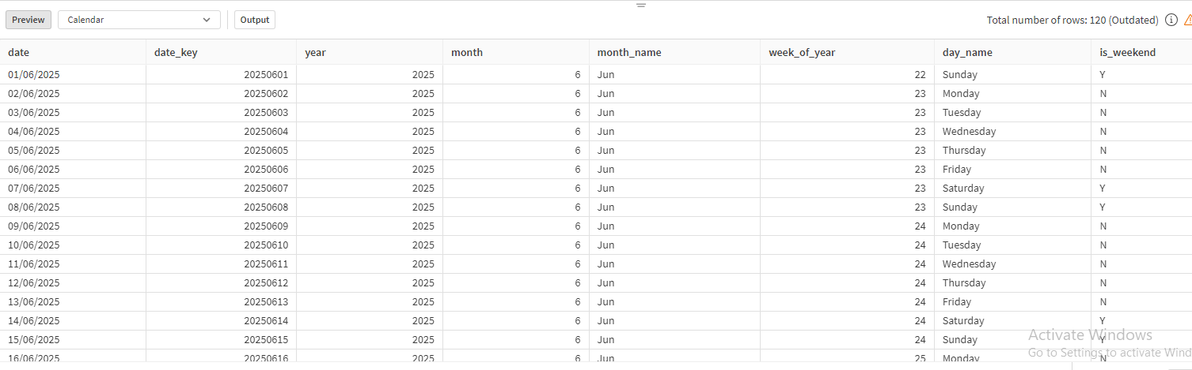
Shift Calendar table before standardizing the date
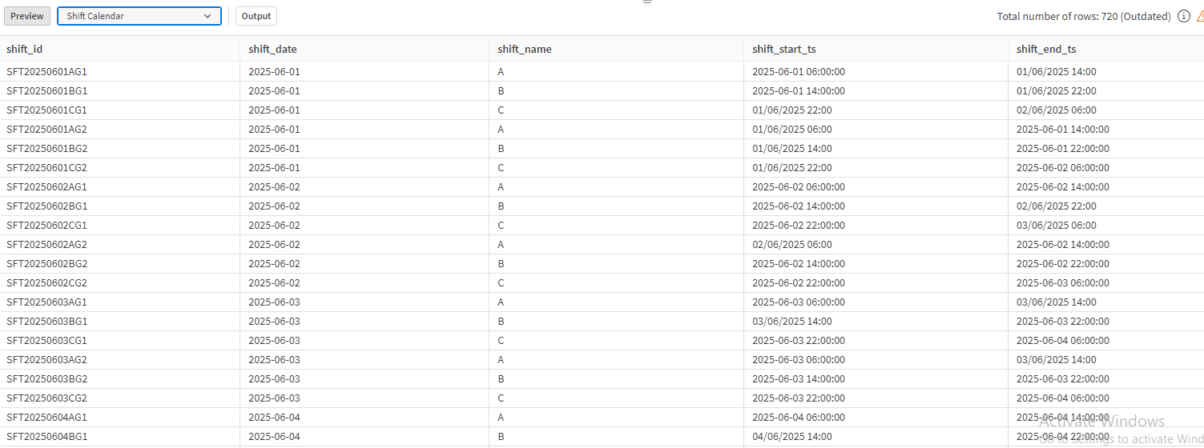
Load Editor Script to standardize the date format into dd/mm/yyyy format
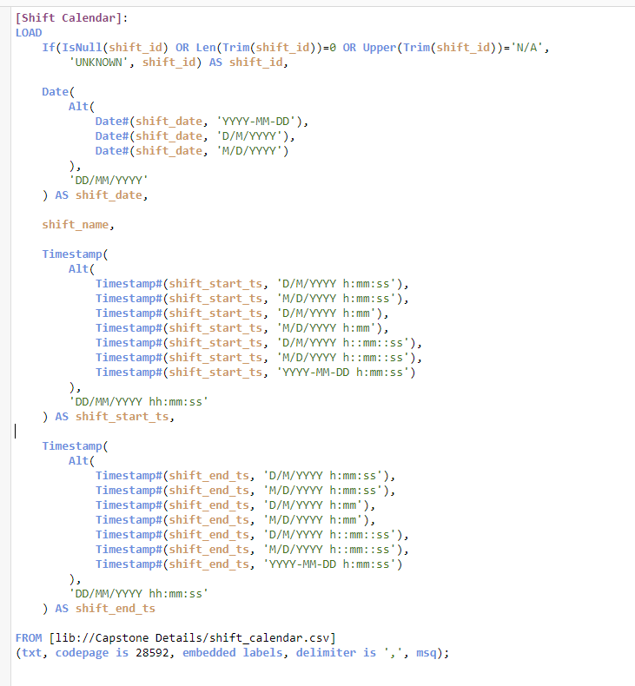
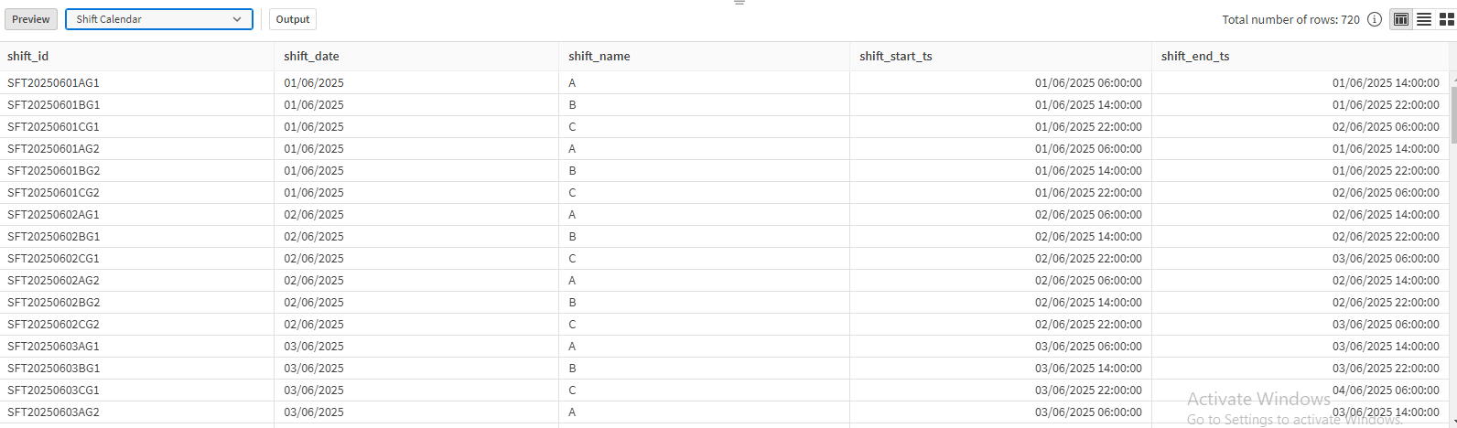
Shift Calendar after standardizing the date format into dd/mm/yyyy

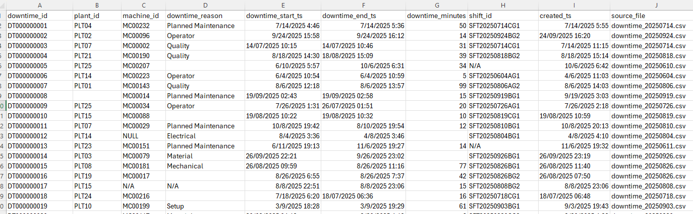
Machine Downtime before cleaning

The plant_id, machine_id, downtime_reason, and shift_id columns contained NULL, ‘N/A’, and ‘UNKNOWN’ values, all of which were consistently replaced with ‘UNKNOWN’ to maintain data integrity. Additionally, blank values in the downtime_minutes column were calculated using the difference between downtime_start_ts and downtime_end_ts to ensure completeness and accuracy of downtime duration data.

Creating a flag column for date violation (downtime_start_ts > downtime_end_ts)
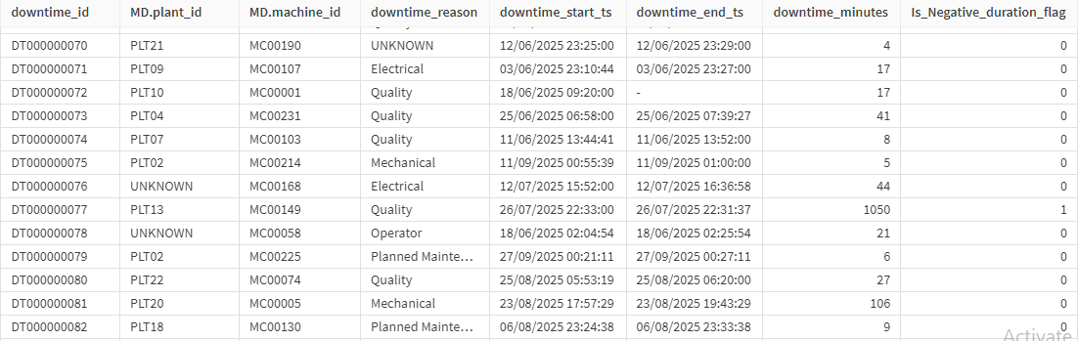

Load Script to handle null values, N/A, UNKNOWN values in plant_id, machine_id, downtime_reason, shift_id columns and standardizing the date formats in downtime_start_ts, downtime_end_ts and created_ts.
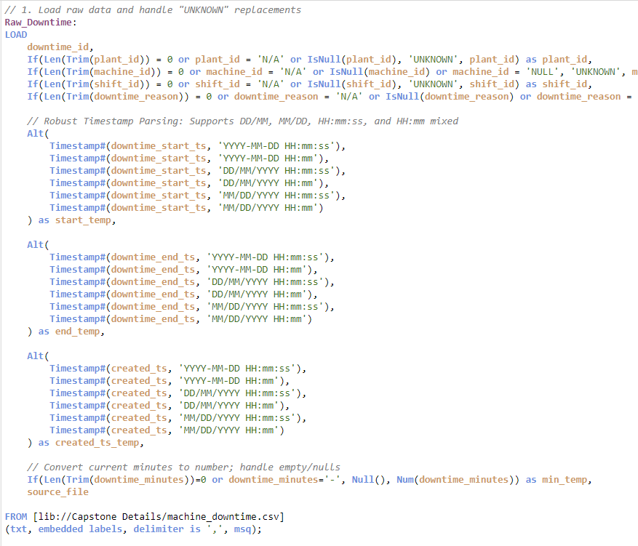
Load Script to handle missing downtime_minutes
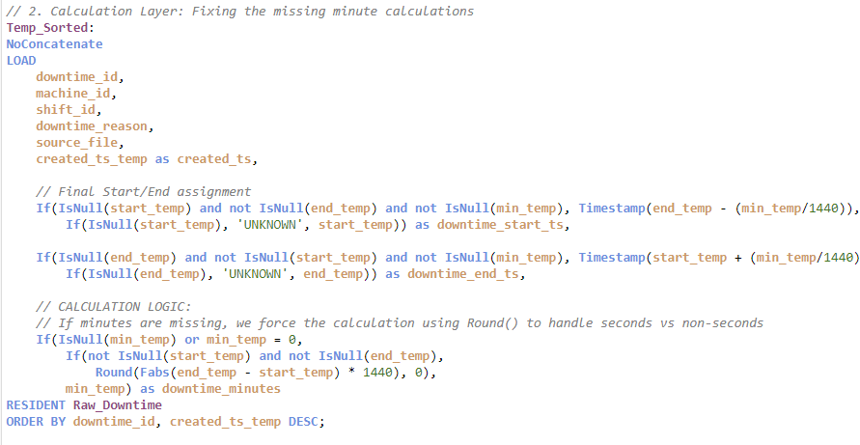
Deduplication logic
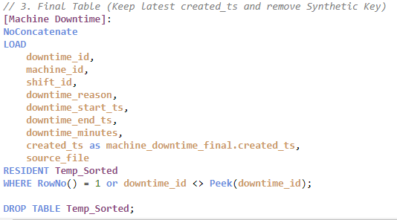
Duplicate records in downtime_id were removed by retaining only the entry with the latest created_ts, ensuring that the most recent and accurate downtime information is preserved.
Row Count before De-duplication : 18180
Row Count after De-duplication : 18000

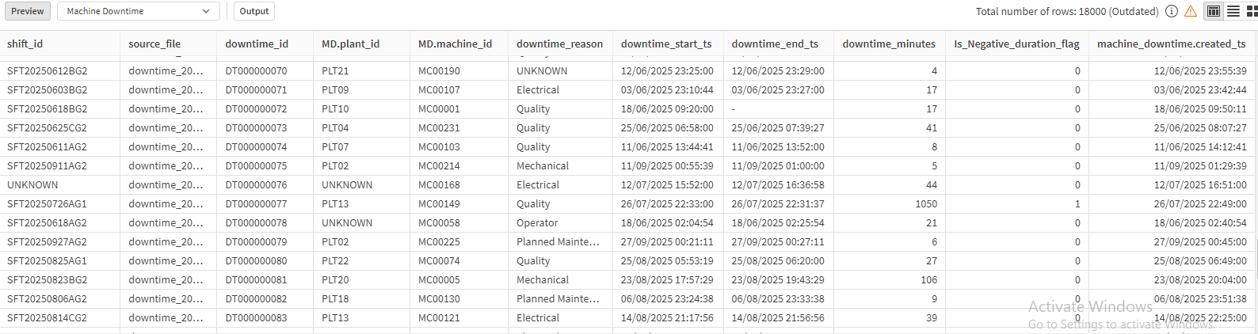
Machine Downtime table after cleaning

Derived DimDowntimeReason Table

Load Editor Script to create DimDowntimeReason Table
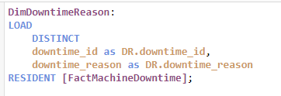

10. Dimension Modelling
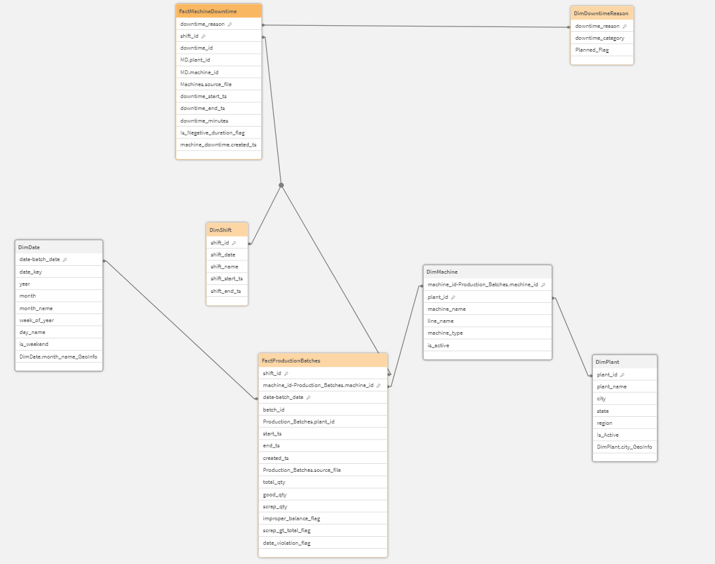

11. Manufacturing Semantics Readiness
- Yield Percentage (Yield %)
Yield percentage was derived to measure production efficiency by comparing good output against total production. It is calculated using the relationship between good_qty and total_qty, ensuring that only valid, non-negative quantities are considered. This metric helps identify process effectiveness and quality performance at batch, machine, and shift levels.
- Downtime Minutes (Derived if Missing)
Downtime minutes were derived for records where the original downtime duration was missing or invalid. In such cases, downtime was calculated using the difference between downtime_start_ts and downtime_end_ts timestamps. This approach ensures that downtime analysis remains complete and reliable without discarding records due to missing duration values.
- Scrap Percentage (Scrap %)
Scrap percentage was derived to quantify material loss during production. It is calculated as the ratio of scrap_qty to total_qty, expressed as a percentage. This metric enables monitoring of waste trends and supports root-cause analysis for quality and process inefficiencies.

Day-3 : KPI Semantics & Downtime / Yield Logic
12. KPI Measure Engineering After Cleaning
- Total Production Quantity = Sum(total_qty)
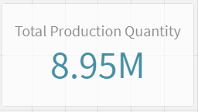
- Good Quantity = Sum(good_qty)
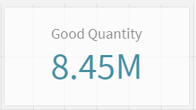
- Scrap Quantity = Sum(scrap_qty)
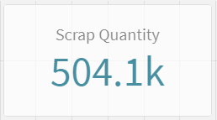
- Yield % = (Sum(good_qty) / Sum(total_qty))
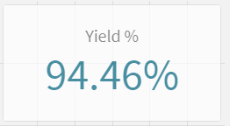
- Downtime Minutes = Sum(downtime_minutes)
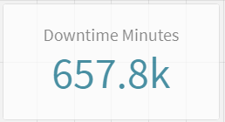
- Uptime % = (
(
Sum( Interval( Timestamp(shift_end_ts) - Timestamp(shift_start_ts), 'mm') ) - Sum( Interval( Timestamp(downtime_end_ts) -Timestamp(downtime_start_ts), 'mm') )
)
/
Sum( Interval( Timestamp(shift_end_ts) - Timestamp(shift_start_ts), 'mm') )
)
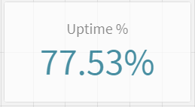

- OEE-style proxy = Availabilty * Quality
(
(
// Availability = (Scheduled - Downtime) / Scheduled
(
Sum( Interval( Timestamp(shift_end_ts) - Timestamp(shift_start_ts), 'mm') )
- Sum( Interval( Timestamp(downtime_end_ts) - Timestamp(downtime_start_ts), 'mm') )
)

/
Sum( Interval( Timestamp(shift_end_ts) - Timestamp(shift_start_ts), 'mm') )
)
*
// Quality = Good Qty / Total Qty
(
Sum(good_qty) / Sum(total_qty)
)
)
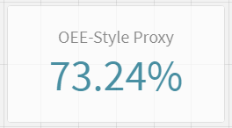
13. Downtime & Yield Logic Validation
- Derived downtime durations :
Downtime durations were validated by comparing calculated downtime minutes, derived from the difference between downtime_start_ts and downtime_end_ts, with the originally provided downtime values where available. Negative or illogical durations were identified using validation flags, ensuring that only logically consistent downtime values were used for analysis while preserving audit visibility for exceptions.

- Yield calculations :
Yield calculations were validated by enforcing the business rule “total_qty = good_qty + scrap_qty”. Missing quantity values were derived only when sufficient information was available, and all calculations were constrained to non-negative values. Records violating logical quantity relationships were flagged to maintain transparency without altering original production figures.

- Partial Batches :
Partial batches, where complete production quantities were unavailable, were handled by deriving missing values only when at least two of the three quantity fields were present. If insufficient data was available, the missing quantities were set to zero and flagged where necessary, preventing distortion of yield metrics while preserving the batch records.

- Missing Downtime Reasons
Records with missing or invalid downtime reasons were standardized by replacing such values with ‘UNKNOWN’. This approach ensured that downtime events were retained for analysis and remained joinable across the data model, while clearly highlighting data quality gaps for further investigation.

14. Parameter & What-If Scenario Analysis

- Downtime threshold
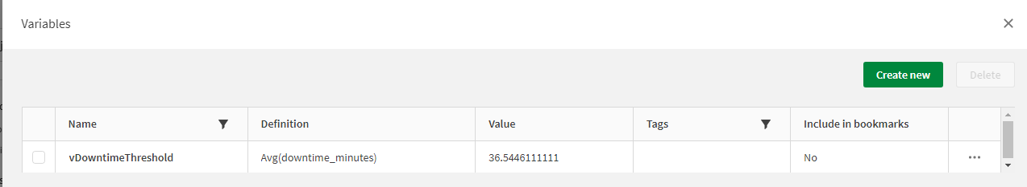
A variable was created to control the downtime threshold, with Avg(downtime_minutes) set as the minimum value and Max(downtime_minutes) set as the maximum value. Using this parameter, three KPIs were developed to display the number of downtime events, plants, and machines that exceed the defined downtime threshold.
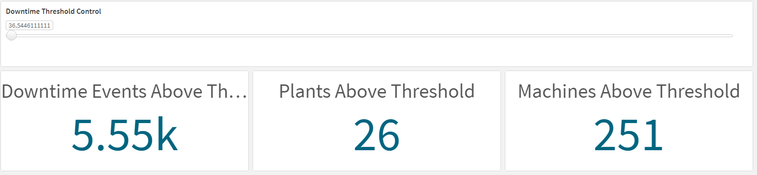
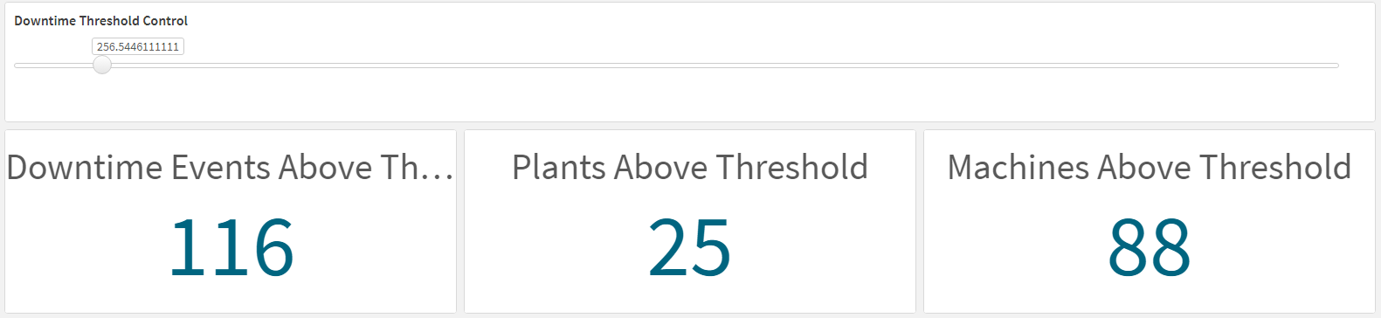

- Yield anomaly threshold

